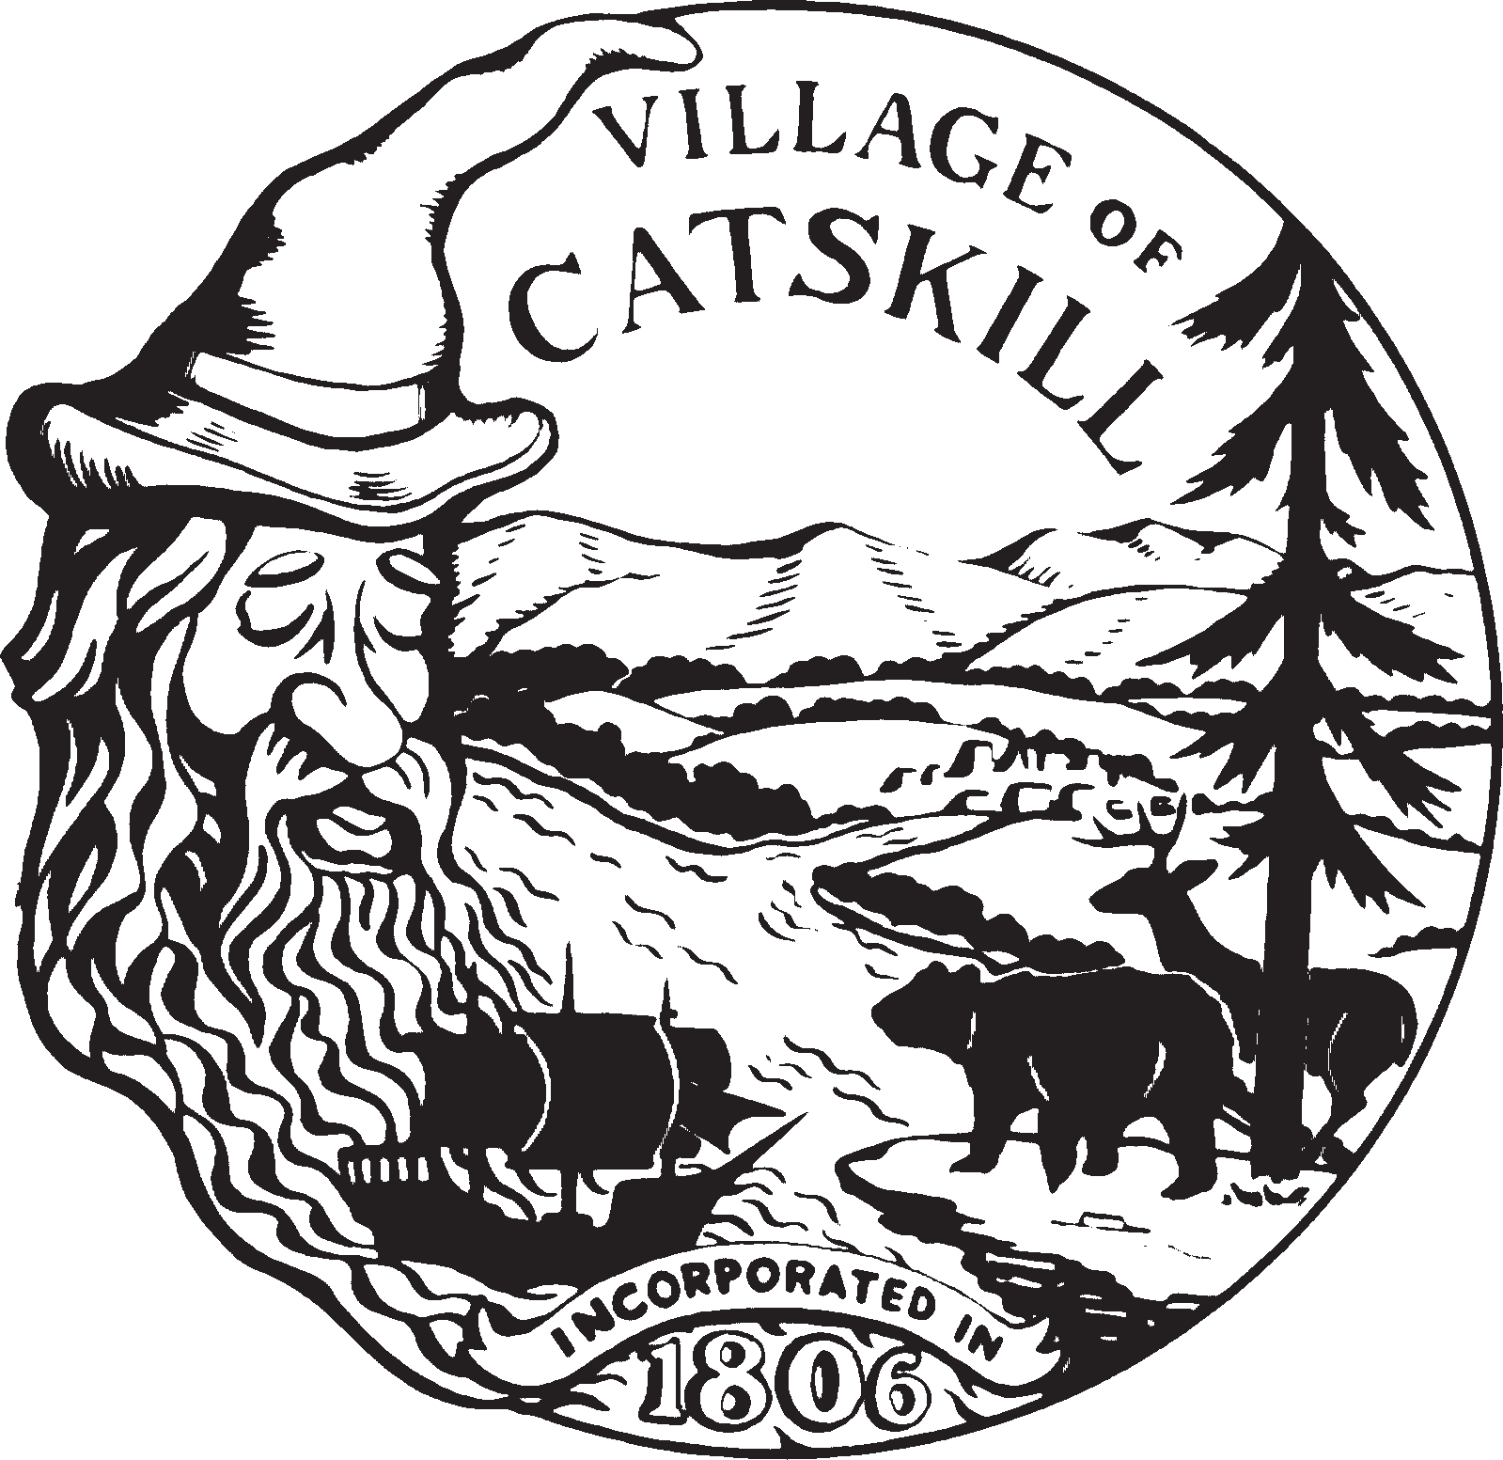

VILLAGE OF CATSKILL
422 MAIN STREET
CATSKILL, NEW YORK 12414
---------------
Tel. (518) 943-3830
Fax (518) 943-7606
TTY 1-800-421-1220

Project Proposal Form

Personal Information
Name: _______________________________________________________________________
Organization (if applicable): ______________________________________________________
Address: ______________________________________________________________________
Phone Number: ________________________________________________________________
Email: ________________________________________________________________________

Project Description
1. Project Title: _________________________________________________________________
2. Brief Description of Project: __________________________________________________________________________________________________________________________________________________________________________________________________________________________________________
3. Project Location: _____________________________________________________________
4. Objective of the Project: ____________________________________________________________________________________________________________________________________________________________
5. Expected Impact on the Community: ____________________________________________________________________________________________________________________________________________________________
6. Proposed Timeline for Project Implementation: ______________________________________________________________________________
7. Estimated Total Project Cost: ___________________________________________________
8. Amount Requested from DRI/NY Forward Grant: ___________________________________
9. Sources of Match Funding (private sector investment): ____________________________________________________________________________________________________________________________________________________________
10. Any Additional Information: ____________________________________________________________________________________________________________________________________________________________

Project Readiness
11. How prepared is the project for implementation (conceptual, planning stage, ready for implementation)? _______________________________________________________________
______________________________________________________________________________
12. Have any permits or approvals been obtained for the project (if applicable)? ____________________________________________________________________________________________________________________________________________________________
13. Are there any potential challenges or obstacles to project implementation? __________________________________________________________________________________________________________________________________________________________________________________________________________________________________________
14. Is the project aligned with the goals and priorities of the DRI/NY Forward grants? ______________________________________________________________________________

Please fill out the above information and submit the completed form to asignoretti@villageofcatskillny.gov for consideration. Thank you for your interest in contributing to the revitalization of the Village of Catskill.

